NAME: Onkar Biyani

EMPID-2127040

EMAILID:2127040@cognizant.com

1. **Create DataFrames by using ddl**

**Given the data sets of json as well as csv , how will you read it as a ddl and by not inferring schema.**

**Datasets : Customer.json web_sales.csv**

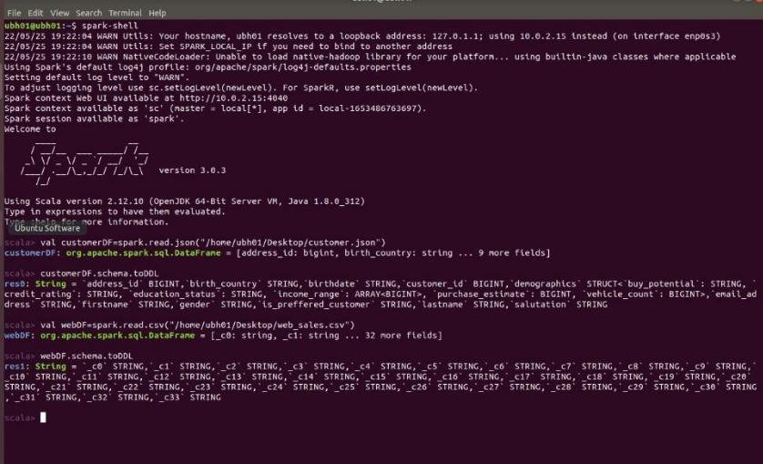

2. How will you inferschema while reading the dataset using struct field?

1. **Dataframe manipulation Cast address_id to longtype cast birthdate to stringtype**

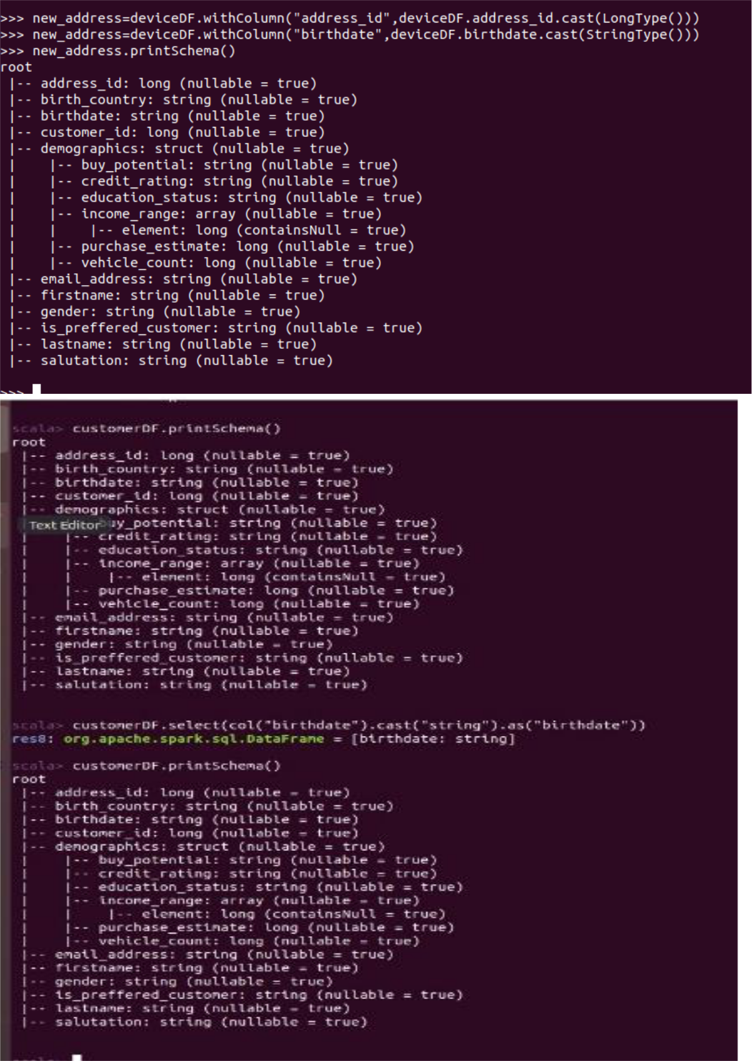

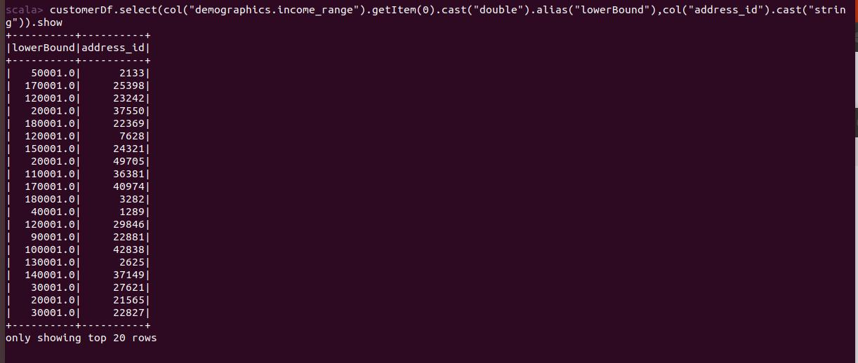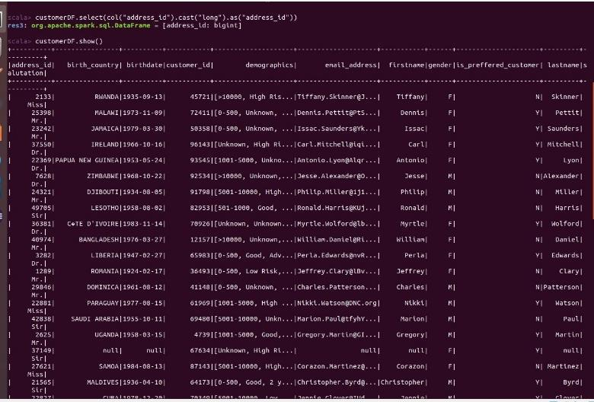

1. **Select "ws_order_number","ws_item_sk", "ws_quantity","ws_net_paid", "ws_net_profit","ws_wholesale_cost" in a new dataframe called as salesStatDf from webSalesDf which comes from web_sales.csv**

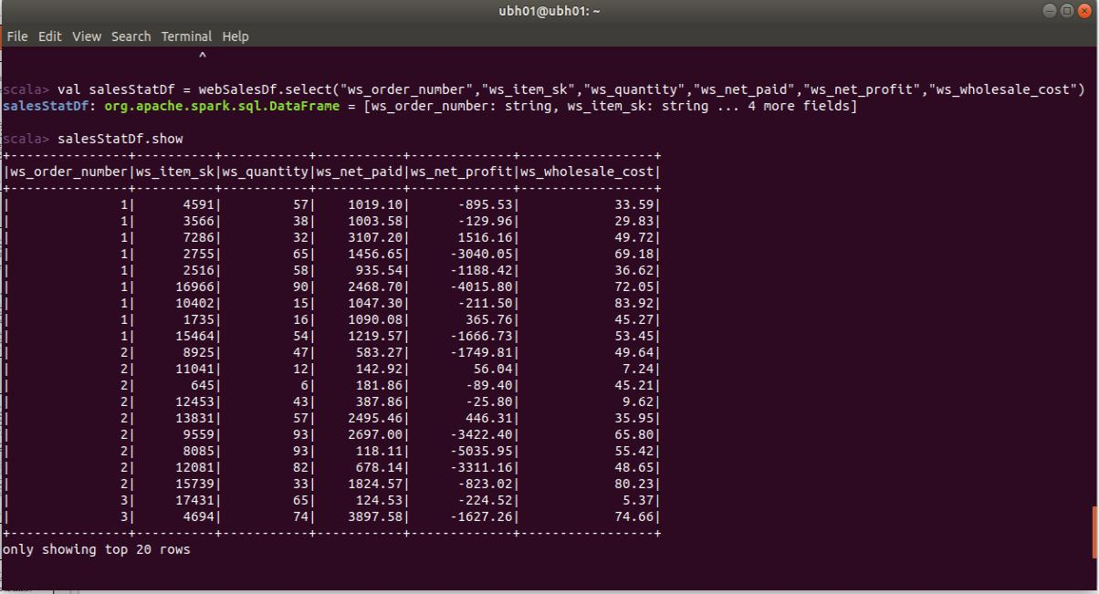

1. **Add columns to salesStatDf**

**expected_net_paid as ws_quantity*ws_wholesale_cost calculated_profit as ws_net_paid-expected_net_paid unit_price as ws_wholesale_cost / ws_quantity rounded_unitPrice as unit_price rounded up to 2 brounded_unitPrice as brounded_unitPrice brounded up to 3**

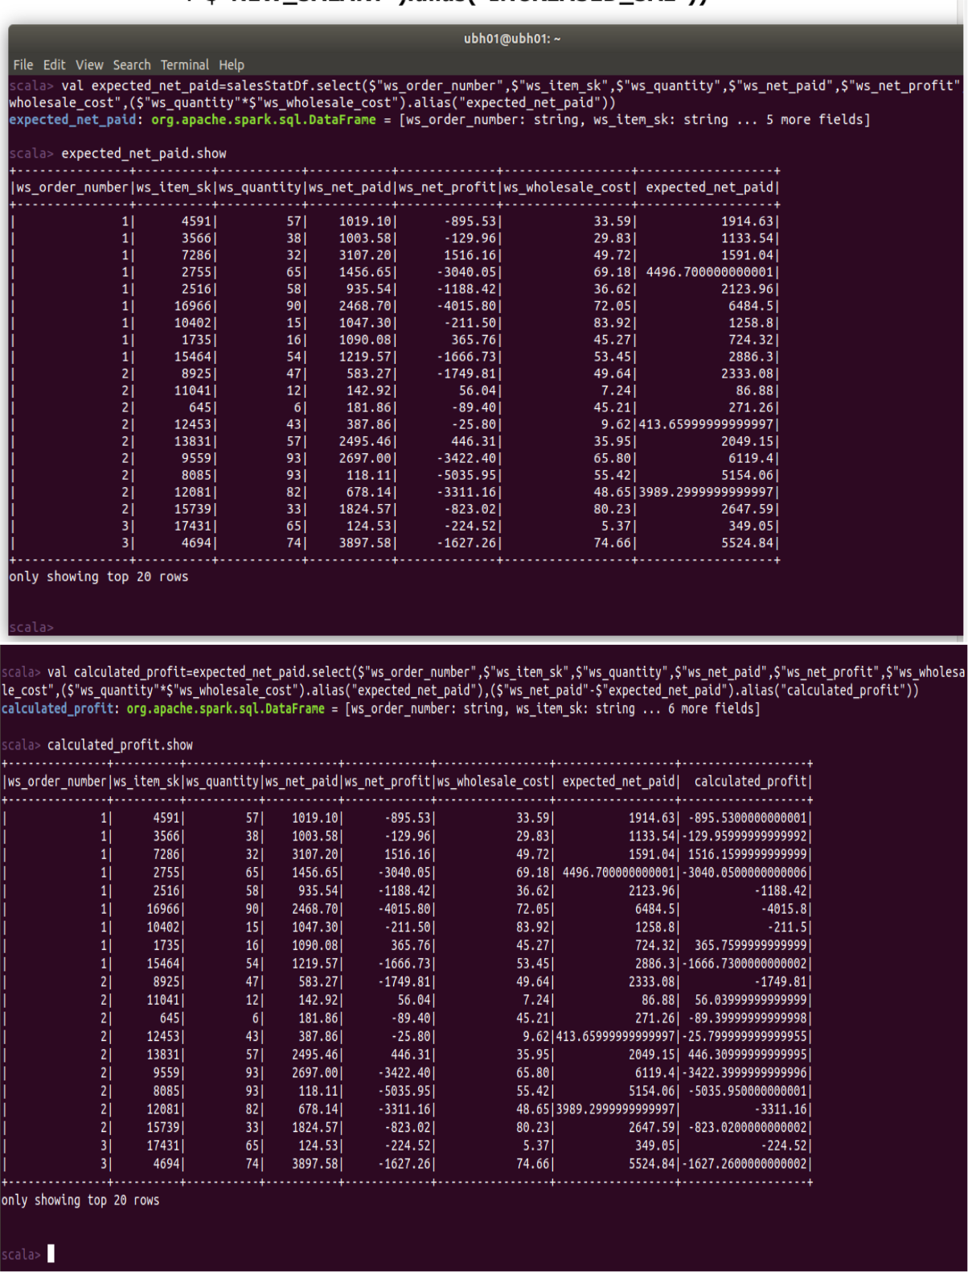

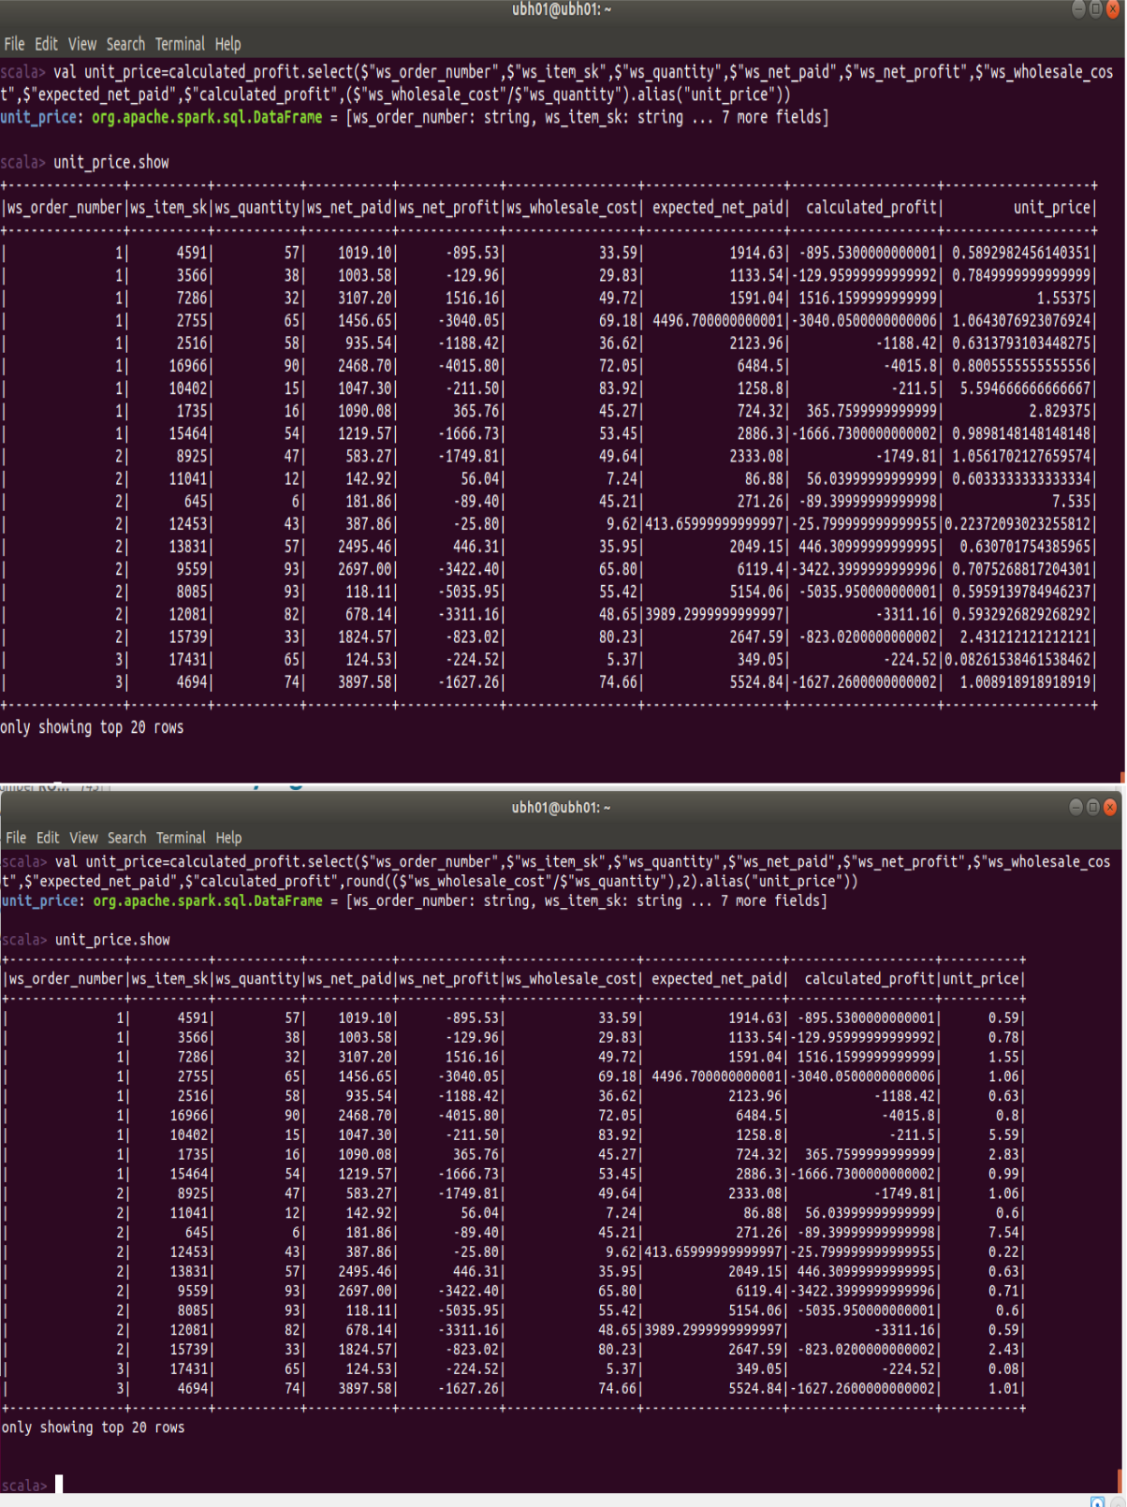

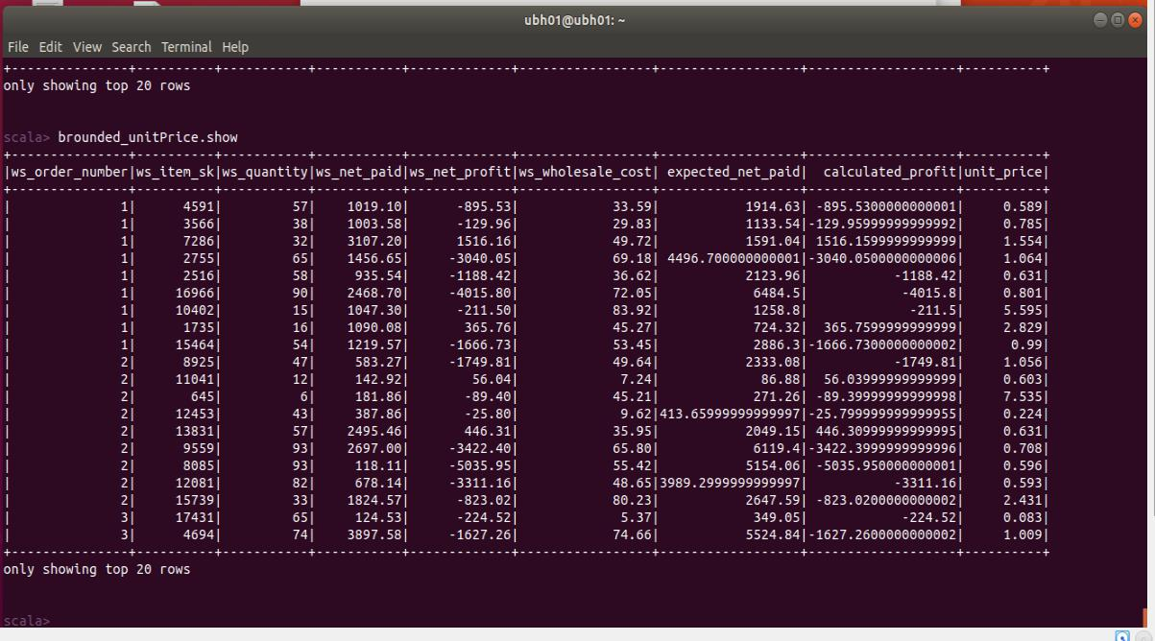

1. **Add columns to df - customerDf**

**by renaming "email_address"to "mail"**

**Adding "developer_site" column by giving default value as insightahead.com" drop birth_country and address_id columns**

**and filter dayofmonth in birthdate < 20 from the customerDf**

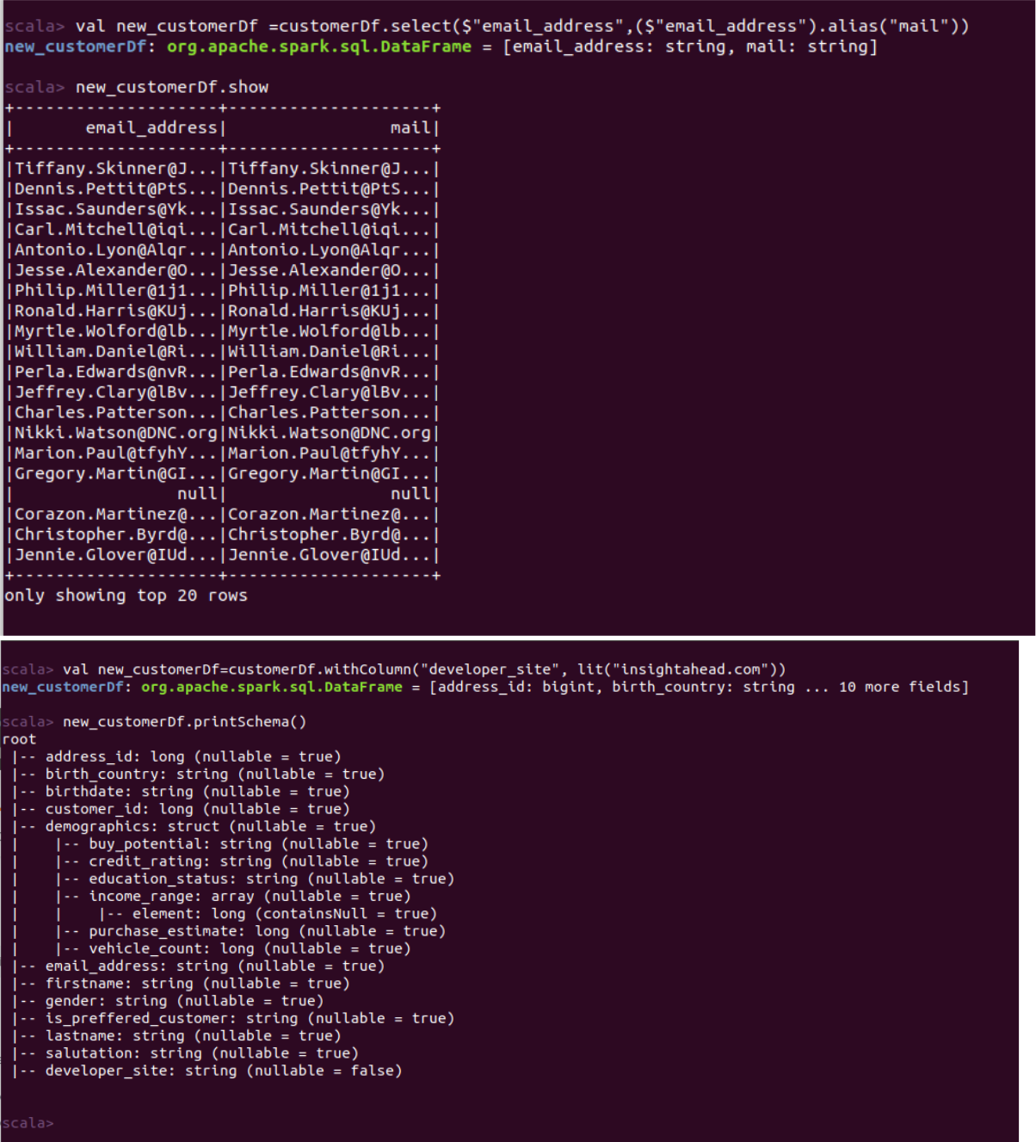

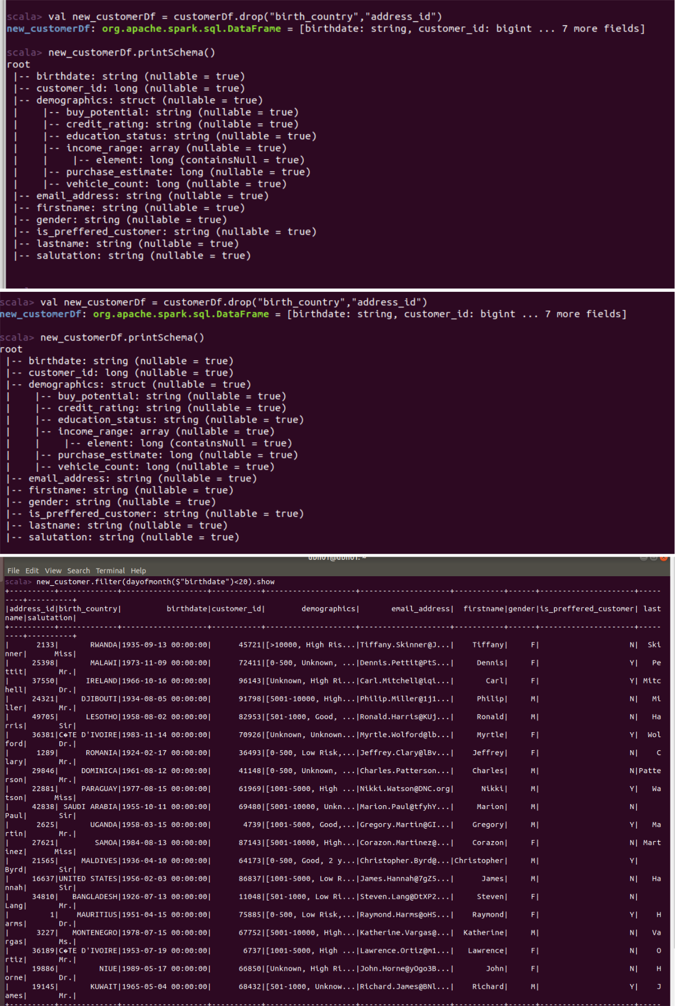

1. **Create df filtered from customerDf by having condition year(birthdate) > 1980 and month as january and day of birthdate > 15 and birth_country is not UNITED STATES,**

**And select the firstname,lastname,birthdate,birth_country**

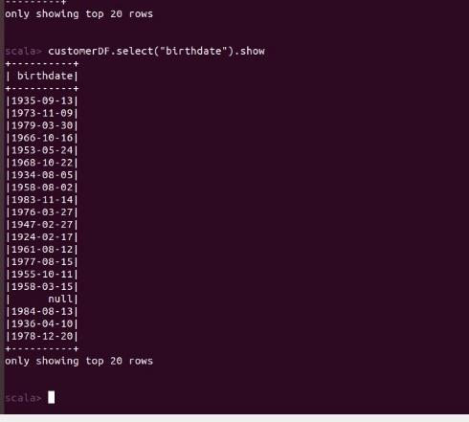

1. **Create dataframe with columns id,name with id as no in the week and the corresponding day**

**Ex : 1 -> Monday**

**...**

**...**

**7 -> Sunday**

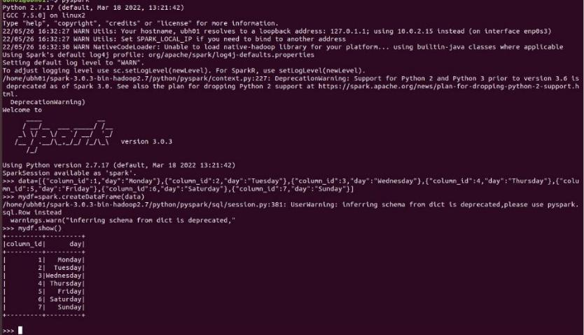

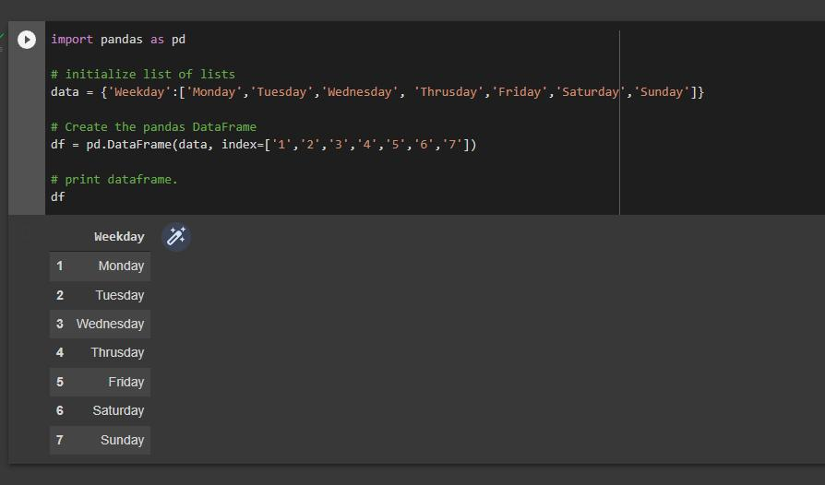

**9.** **From CustomerDF select salutation column count with null**

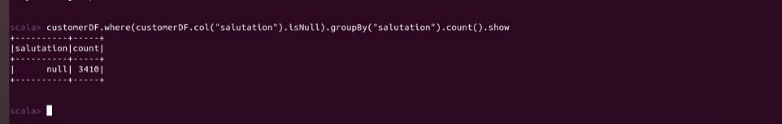

**10. From CustomerDF select salutation column count with not null**

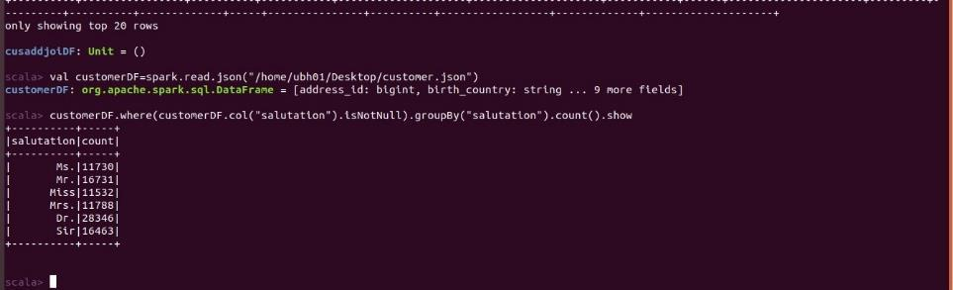

**11. Drop with 2 types-> all and any**

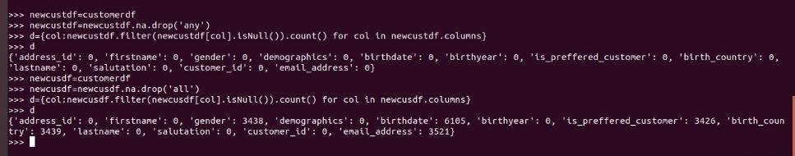

**12. How to fill na element with the below**

**"salutation" -> "UNKNOWN",**

**"firstname" -> "John",**

**"lastname" -> "Doe",**

**"birthyear" -> 9999**

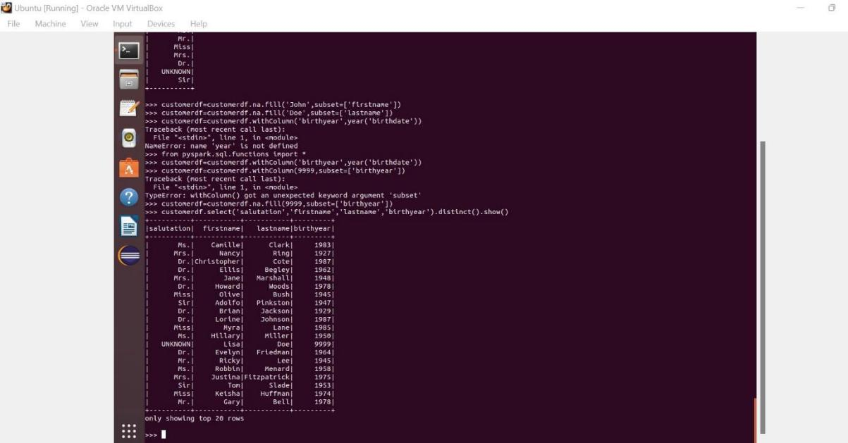

**13. Sort customerDF -> firstname,lastname in desc**

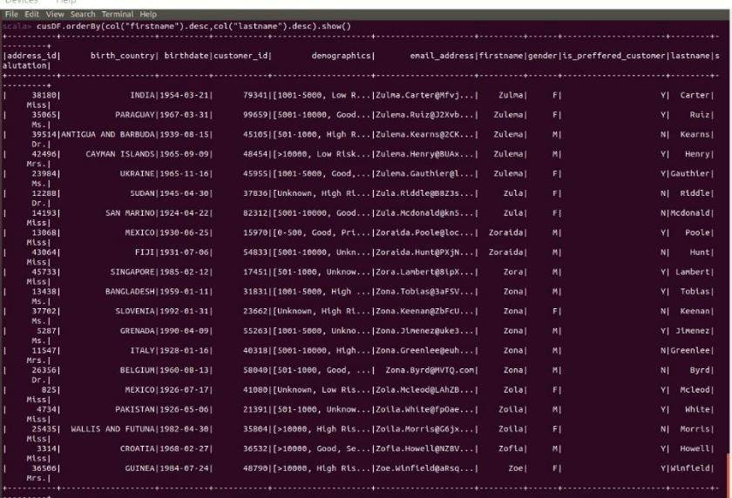

1. **Find the behavior of customerPurchase from the above mentioned dattaframe**
2. **CustomerPurchases grouped on customer_id and aggregate on count(item_id)**
3. **Aggregate on ws_sales_price ,min,max,avg,mean,count**

**MAX**

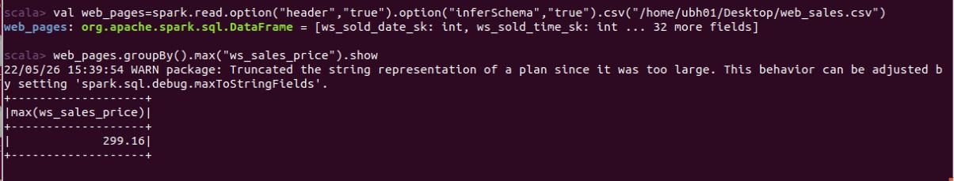

**MIN**

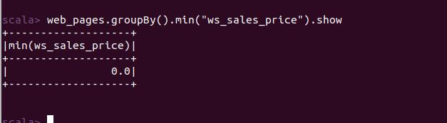

**MEAN**

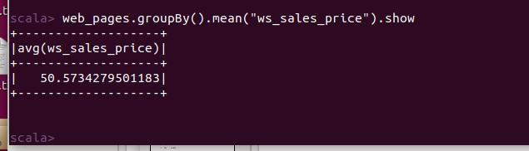

**COUNT**

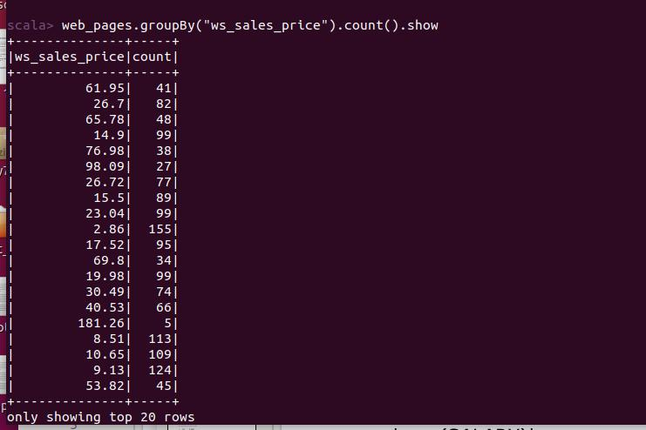

**AVG**

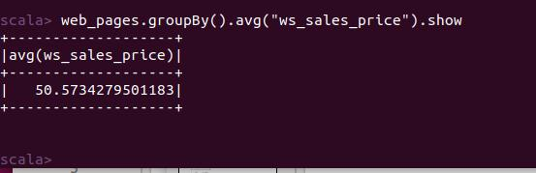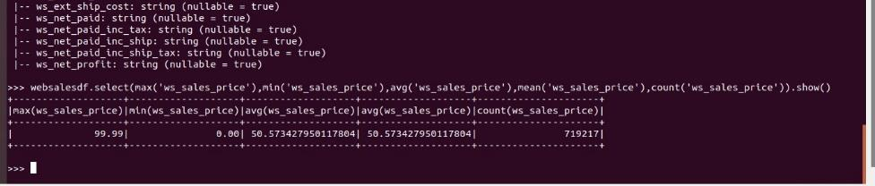

1. **Describe,summary,printShcmea on dataframework**
2. **Join customerDf,addressDf based on address_id , get matching data by inner join**

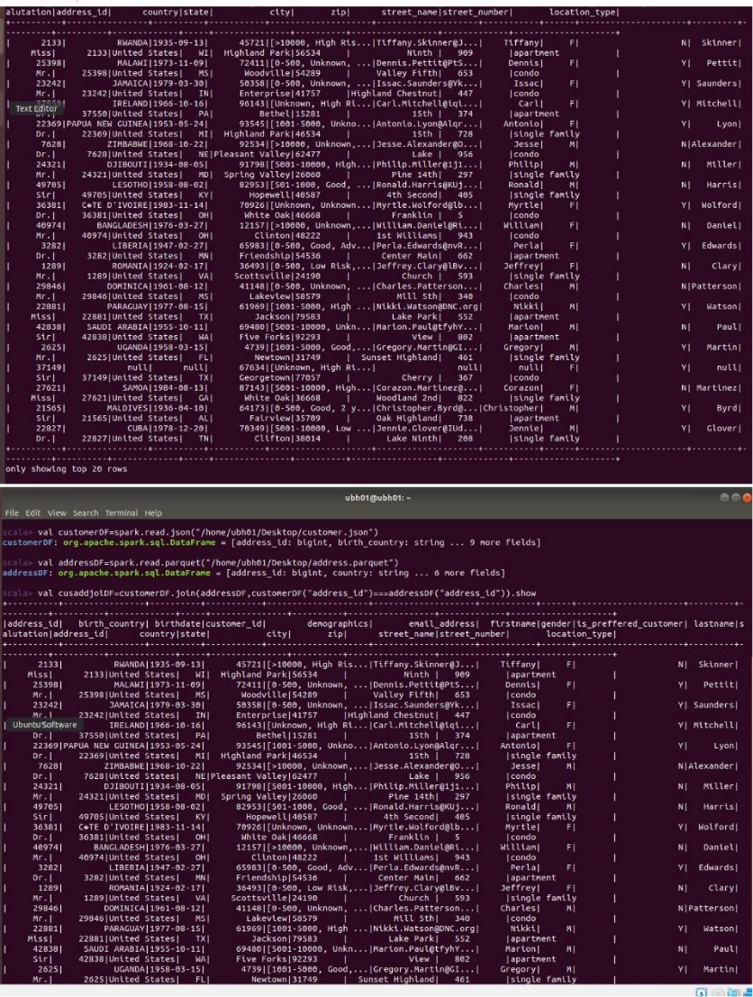

**19. join customerDf,webSalesDf where customer is not null**

